Tutorial 7
Q1
Describe memory-mapped I/O and direct I/O. Give the main advantages and main disadvantages of each.

Memory Mapped I/O
Port devices are addressed and selected by decoders as if they were memory devices.

Advantages :
Addressed and selected like a memory device. i.e. all the memory reference operations and addressing modes can be used for I/O ports.

Disadvantages :
Some system memory address space is used up for ports and is therefore not available for memory, thus the total space for memory is reduced.

Direct I/O
Using a separate address space for I/Os.

Advantages:
Not using the system memory address space.

Disadvantages:
Only special IN and OUT instructions can be used for I/O operations.
Not all CPUs support direct IO.

Q2
In a PIC18 system, the addresses of the status register & data register of an input device are E00H & E01H, in data memory space, respectively. When bit 0 of the status register is 1, the data to be input by CPU is ready. Both status & data registers are 8-bits long. Write the instruction sequences using to check the status register continuously and input the data when data is ready.

Main ORG 0x0000
MOVLB 0xE0
MOVLW 0x01
Again CPFSEQ 0x00, 1
bra Again
MOVF 0x01, w, 1

End

Q3
Suppose that there is a 12-bit ADC with and . Find the corresponding voltage values for the A/D conversion results of 80, 180, 480, 640, 960, 1600, 2048, 3200 and 4000.

Use this equation: 

Q4
Determine the output voltage of the following circuit.

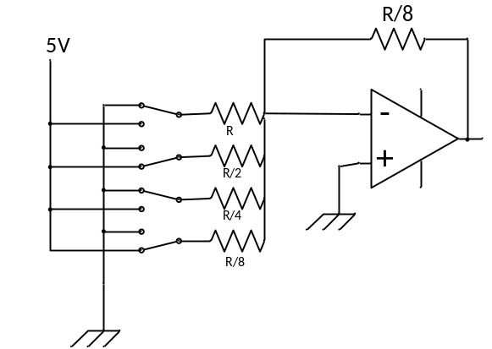

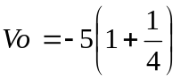

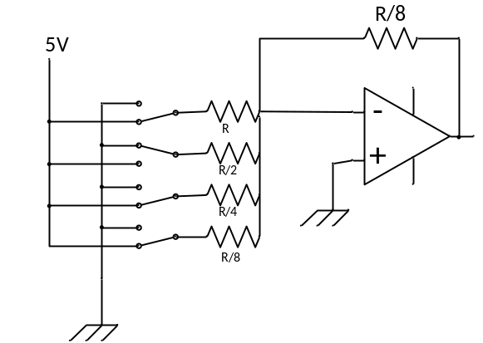
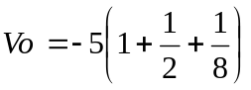
- Q5 For the following ADC circuit, let Vref = 1 V.
Determine the output of the comparators and the binary output if

(a) Vin=0 (b) Vin=0.23 (c) Vin=0.51 (d) Vin = 0.8

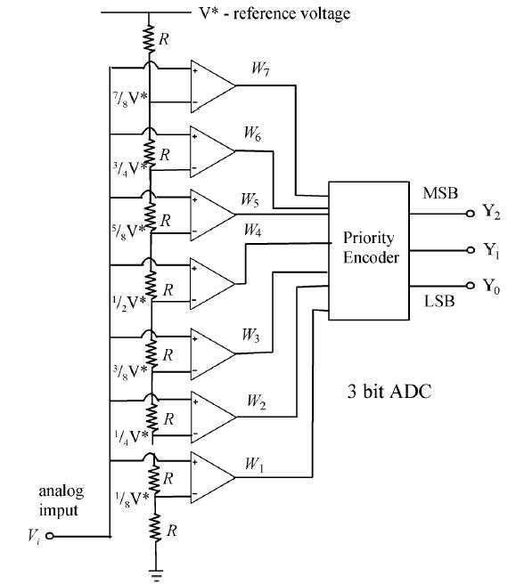
(a) 000 0000 binary output=000
(b) 000 0001 binary output=001
(c) 000 1111 binary output=100
(d) 011 1111 binary output=110

Q6 Assume f_{OSC} = 10MHz, Calculate the conversion time per bit (T_{AD} ) for all possible ADCS2:ADCS0.

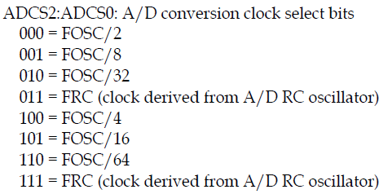

000 = fosc/2 => 200 ns
100 = fosc/4 => 400ns
001 = fosc/8 => 800 ns
101 = fosc/16 => 1.6 μs
010 = fosc/32 => 3.2 μs
110 = fosc/32 => 6.4 μs

Q7 The PIC18F4520 has an on-chip ADC.
T

Q8 The unused analog pins of the PIC18F4520 can be used for digital IO pins.
T

Q9 The ADC module of the PIC18F4520 can convert only one channel at a time.
T

Q10 With Vref+=2.56V and Vref-=0V, find the Vin for the following outputs:

(a) 11 1111 1111 (b) 10 0000 0001 (c) 11 0011 0000

Step Size = 2.56/1024 = 2.5 mV
(a) 1023 x 2.5 mV = 2.5575V
(b) 513 x 2.5mV = 1.2825V
(c) 816 x 2.5 mV = 2.04V

Q11 Find the value for ADCON1 and ADCON2 if we want Tad=fosc/4, Tacq=8Tad, 4 channels of analog inputs with external source for Vref+ and Vref- and left-justified output.

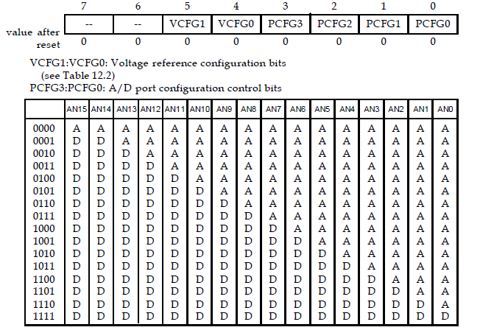
ADCON1=0011 1001 (why not 1011)

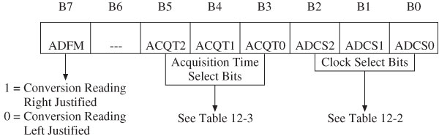

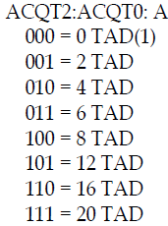
ADCON2=00 100 100

Q12
Assume f_{OSC} = 4MHz, write a few instructions to configure PIC18F4520 ADC with the following requirements:
  - ADC converts the analog signal fed into Channel AN3.
  - Set AN0 to AN3 as analog inputs, other A/D port pins for digital I/O.
  - ADC result is left justified.
  - Select V_{DD} and V_{SS} as reference voltages.
  - Select the minimum possible T_{AD}
  - Select the minimum possible T_{ACQ}
  - Turn on ADC module
Do not start ADC yet
T_{AD} must be at least 0.7us and T_{ACQ} must be at least 1.4μs.

Ans: T_{AD} must be at least 0.7us. For f_{OSC} = 4MHz or T_{OSC} = 0.25us, the minimum possible T_{AD} that can be chosen is 4T_{OSC} or 1us.
T_{ACQ} must be at least 1.4μs. T_{AD} = 1μs. T_{ACQ} >= 2 T_{AD}

movlw b’00001101’
movwf ADCON0
movlw b’00001011’
movwf ADCON1
movlw b’00001100’
movwf ADCON2

Q12
Assume that the AN0 and AN1 pins of a PIC18 running with a 4 MHz crystal oscillator are connected to a potentiometers. The voltage range of the potentiometer is from 0V to 5V. The reference external sources Vref+=5V and Vref-=0 are used.

Write a program to measure the voltages applied to the AN0 and AN1 pins, convert them, and retrieved the conversion result and place it in RAM location 0-3.
Let the minimum value of T_{AD} = 1.6 μs and the minimum value of T_{ACQ} = 10 μs

ADCON1= 0011 1011 = 0x3B

T_{AD} must be at least 1.6us. For f_{OSC} = 4MHz or T_{OSC} = 0.25us, the minimum possible T_{AD} that can be chosen is 8T_{OSC} or 2us. => f_{OSC}/8 =>001

T_{ACQ} must be at least 10μs. T_{AD} = 2us. T_{ACQ} = 6 T_{AD} =>011

ADCON2=10 011 001 = 0x99

start
movlw 0x3B ; useAN2 and AN3 as reference voltages
movwf ADCON1 ; configure channel AN0-3 as analoginput
movlw 0x99 ; select FOSC/8 as conversion clock,
movwf ADCON2 ; 6 TAD for acquisition time,
;right-justified

movlw 0x01 ; select channel AN0 and enable A/D
movwf ADCON0
bsf ADCON0,GO,A ; start A/D conversion
wait_con0
btfsc ADCON0,DONE,A ; wait until conversion is done
bra wait_con0
movff ADRESH, 1 ; save conversion result
movff ADRESL, 0 ; "

movlw 0x05 ; select channel AN1 and enable A/D
movwf ADCON0
bsf ADCON0,GO,A ; start A/D conversion
wait_con1
btfsc ADCON0,DONE,A ; wait until conversion is done
bra wait_con1
movff ADRESH, 3 ; save conversion result
movff ADRESL, 2 ; "

end

Q13
(a) Derive an expression for V_{out.}
(b) Choose appropriate resistor values and the adjusting voltage so that the circuit shown in the last
page can shift the voltage from the range of –5V ~ 5V to the range of 0V ~ 3.3V.

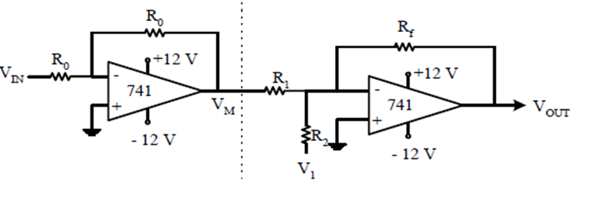
(a)
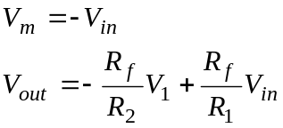

(b)
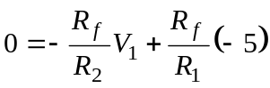

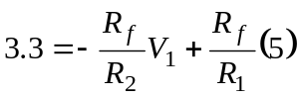

Choose V1=-1.1
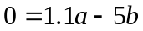
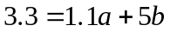

=>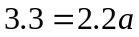=>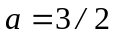

=>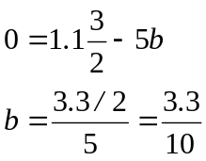

Q14
Describe the double handshake between two devices.

The sender asserts its STB line low to ask the receiver if it is ready. (2) The receivers, if ready, will respond by sending the ACK signal. (3) The sender then sends the data and raises its STB line high. (4) After taking the data, the receiver acknowledges it by letting ACK low.

